**Restaurant Management System**



An

Object-Oriented Programming through Java Course Project Report

in partial fulfilment of the degree

**Bachelor of Technology**

in

**Computer Science & Engineering**

**By**

SUSHANTH.G 2203A51L13

Under the guidance of

SRAVAN.P

Asst Professor

**Submitted to**



i



**DEPARTMENT OF COMPUTER SCIENCE & ENGINEERING**

**CERTIFICATE**

This is to certify that the **Object Oriented Programming through Java - Course Project** Report entitled “**Restaurant Management System”** is a record of Bonafide work carried out by the student Sushanth.G bearing Roll No(s) 2203A51L13 during the academic yea r 2023-24 in partial fulfillment of the award of the degree of ***Bachelor of Technology*** in **Computer Science & Engineering** by the **SR University School of sciences**

**Lab In-charge Head of the Department**

ii

**Table of COntents**

TOPIC: Page No:

1. Title page i
2. Certificate ii
3. Table of Contents iii
4. Abstract iv
5. OBJECTIVE OF THE PROJECT 1
6. DEFINITIONS OF THE ELEMENTS USED IN THE PROJECT 2
7. DESIGN 3-7
   1. Login as Page
   2. CustomerLogin page
   3. Register Page
   4. Home page
   5. AboutUs page
   6. Menu page
   7. Reviews page
   8. ContactUs page
   9. RestaurantLogin page
   10. Menu Management Page
8. IMPLEMENTATION 8-46
   1. Login as page
   2. Customerlogin page
   3. HomePage
   4. AboutUs page
   5. Menu page
   6. Reviews page
   7. Contact us Page
   8. Restaurant Login page
   9. Menu Management page
   10. Register Page
9. RESULT SCREENS 47-50
10. CONCLUSION 51

**ABSTRACT**

The restaurant industry is a dynamic and highly competitive field,requiring efficient management systems to meet customer demands and stay ahead of the competition. This abstract presents a Restaurant Management System (RMS) designed to display menus that can be easily added, displayed, and updated in a user-friendly manner. This system offers restaurateurs a comprehensive solution to streamline menu management and enhance customer experiences.

In summary, the Restaurant Management System outlined in these abstract addresses the needs of modern restaurant management by offering a platform that simplifies the process of adding, displaying, and updating menus. The system improves customer engagement, streamlines operations, and helps restaurants adapt quickly to changing market demands, making it an invaluable tool for restaurant owners and managers seeking to thrive in a competitive industry.

Iv

**OBJECTIVE OF THE PROJECT**

In the dynamic and fast-paced world of hospitality, the need for an efficient and customer-friendly Restaurant Management System is paramount. Our project is dedicated to streamlining the dining experience for both customers and staff by introducing a robust system that places control directly in the hands of the restaurant admin.

Key Features:

Dynamic Menu Management:

The system empowers the admin to easily add, update, or delete dishes from the menu, ensuring that customers are always presented with the most accurate and up-to-date options.

This dynamic menu management not only saves time for customers but also eliminates the need for waitstaff to verbally communicate menu changes.

Real-time Availability:

Customers can confidently choose from the menu, knowing that it accurately reflects the availability of dishes on that specific day.

This feature significantly reduces the time spent by waiters describing dishes and prevents disappointments due to unavailability.

User-Friendly Interface:

The system boasts an intuitive and user-friendly interface for both admin and customers, ensuring a seamless experience for all stakeholders.

Admins can effortlessly navigate through the backend to manage the menu, while customers enjoy a hassle-free menu selection process.

Scope for Future Enhancements:

As the hospitality industry continues to evolve, our Restaurant Management System provides a solid foundation for future enhancements:

Online Ordering: Integrate an online ordering system, allowing customers to place orders remotely.

Table Reservations: Implement a reservation system for customers to book tables in advance.

Feedback Mechanism: Include a feedback system for customers to share their dining experiences, aiding in continuous improvement.

1

**DEFINITIONS OF ELEMENTS USED IN PROJECT:**

**JFrame:** The main window of the application.

**JPanel (contentPane):** The main container for organizing components.

**JLabel:** Display text or image. Used for the application title.

**JTable:** provides a tabular view for displaying data.

**JButton:** A button that performs actions, such as navigation to different sections.

**ActionListener:** Interface to handle button click events.

**ImageIcon:** Represents an image, used for buttons with icons.

**Dispose():** Closes the current window.

**setVisible():** Sets the visibility of the window.

**EventQueue.invokeLater():** Ensures that UI updates are done on the event dispatching thread.

**JTextField, JPasswordField:** For user input (username and password).

**JOptionPane:** Displays dialog boxes, used for showing error messages.

**JScrollPane:** Allows scrolling through reviews.

**ImageIcon:** Represents user icons and rating icons.

**JDBC (Java Database Connectivity):** Establishes a connection to a MySQL database.

Statement: Used to execute SQL queries.

**ClassNotFoundException:** Exception handling for database connection.

2

**DESIGN:**

3.1)Login as Page:

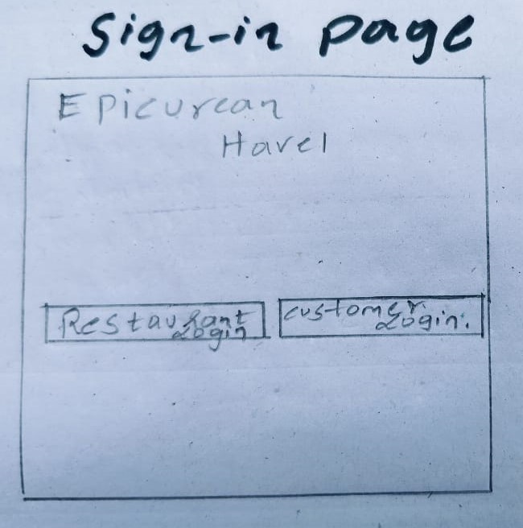

3.2)CustomerLogin Page:

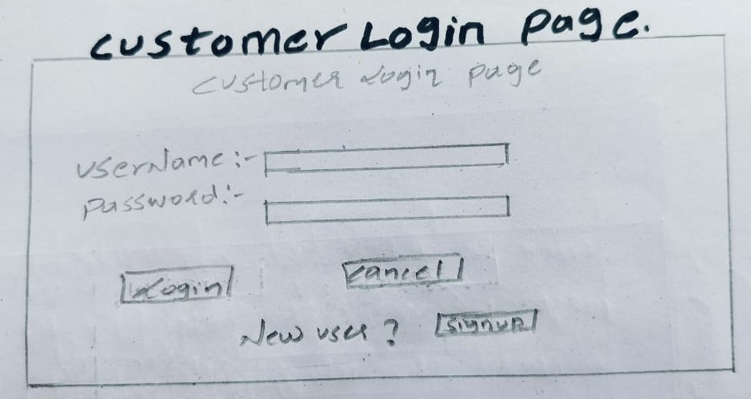

3

3.3)Registeration Page:

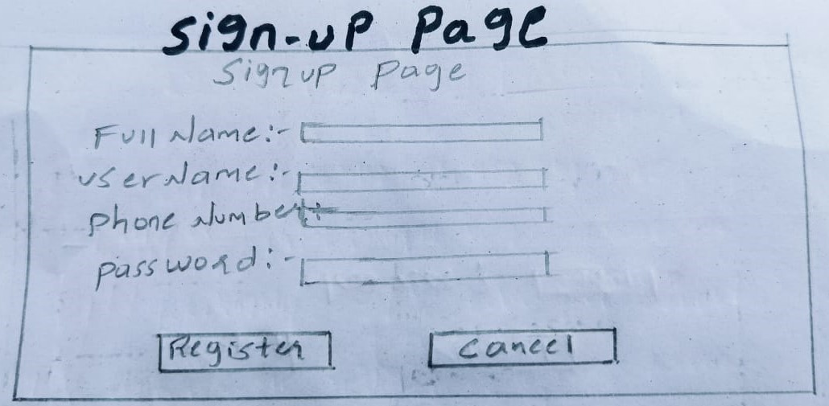

3.4)CustomerLogin Page:

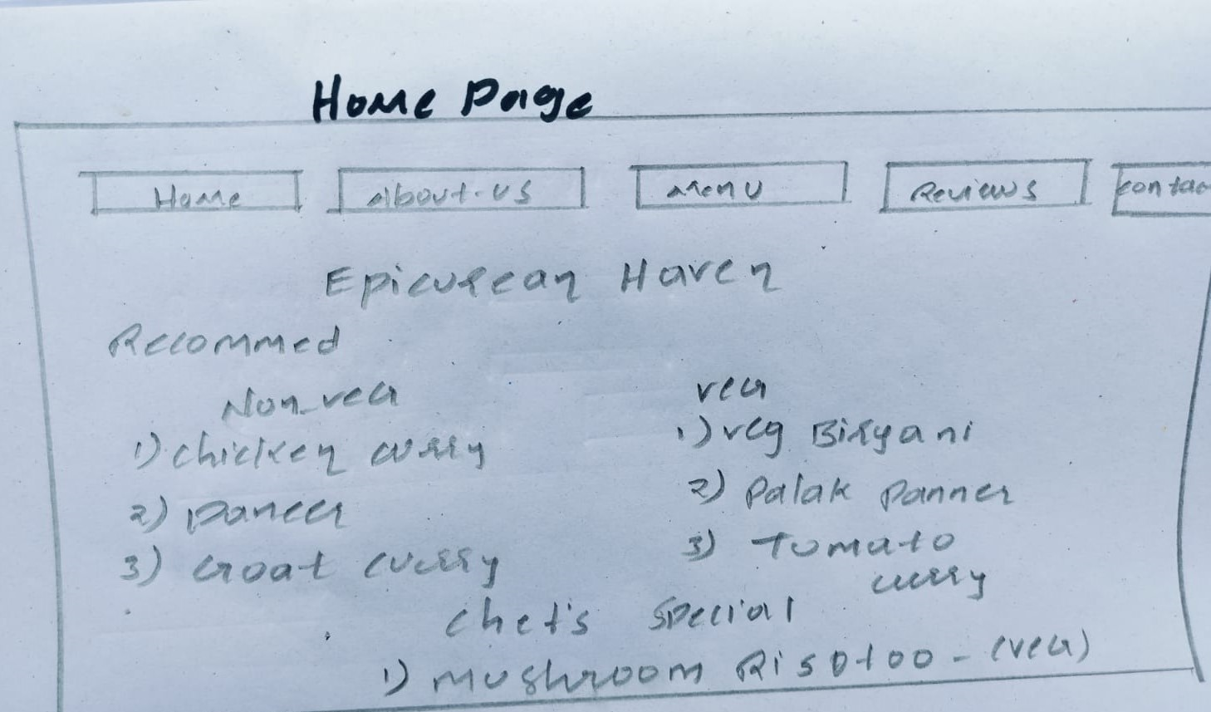

4

3.5) AboutUs Page:

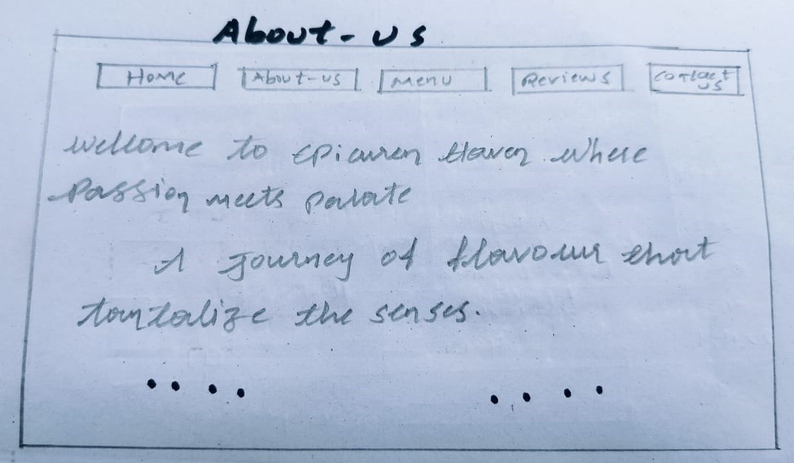

3.6)Menu Page:

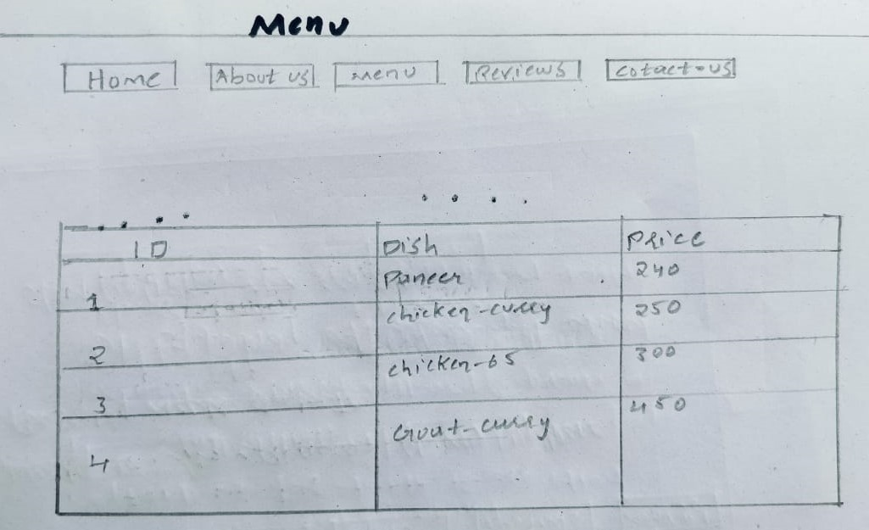

5

3.7)Reviews Page:

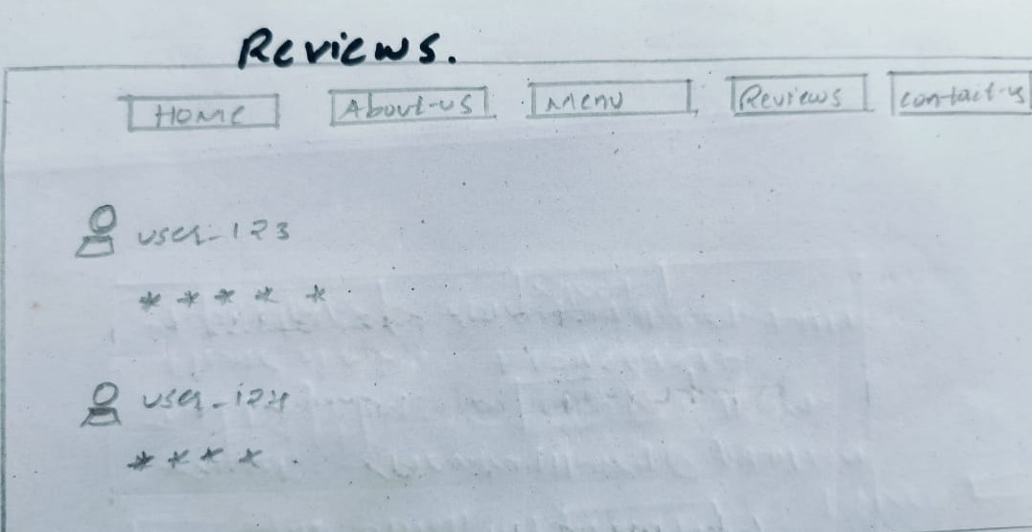

3.8)Contact Page:

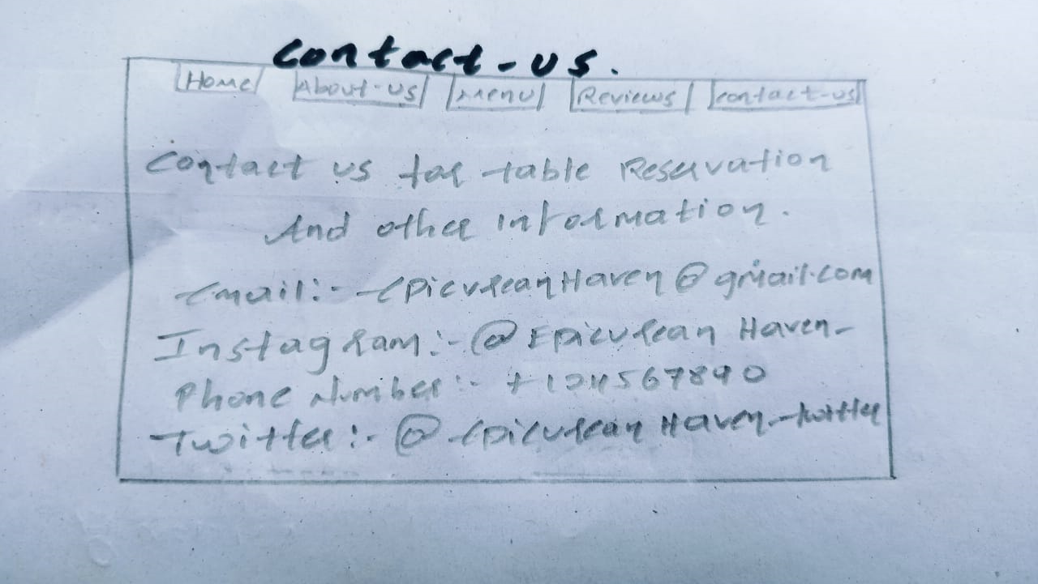

6

3.9)Restaurant Login Page:

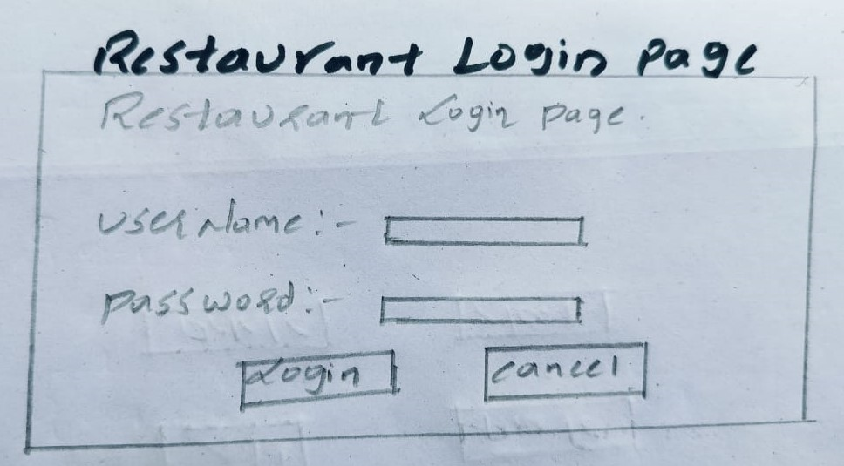

3.10)Admin Menu Management Page:

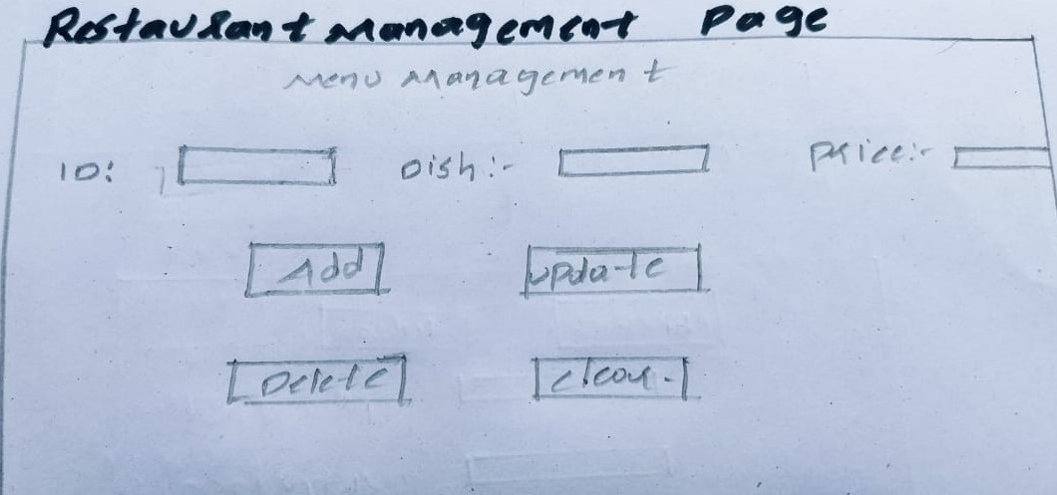

7

**IMPLEMENTATION:**

4.1)Login as Page:

package javaProject1;

import java.awt.EventQueue;

import javax.swing.JFrame;

import javax.swing.JButton;

import java.awt.Font;

import javax.swing.JLabel;

import java.awt.event.ActionListener;

import java.awt.event.ActionEvent;

import javax.swing.SwingConstants;

import java.awt.Color;

public class loginpage {

private JFrame frmEpicureanhavencom;

/**

* Launch the application.

*/

public static void main(String[] args) {

EventQueue.invokeLater(new Runnable() {

public void run() {

try {

loginpage window = new loginpage();

window.frmEpicureanhavencom.setVisible(true);

} catch (Exception e) {

e.printStackTrace();

}

}

});

}

/**

* Create the application.

*/

public loginpage() {

initialize();

frmEpicureanhavencom.setVisible(true);

}

private void initialize() {

frmEpicureanhavencom = new JFrame();

frmEpicureanhavencom.setBounds(100, 100, 1348, 826);

frmEpicureanhavencom.setDefaultCloseOperation(JFrame.EXIT_ON_CLOSE);

frmEpicureanhavencom.getContentPane().setLayout(null);

8

JButton btnNewButton = new JButton("Restaurant login");

btnNewButton.addActionListener(new ActionListener() {

public void actionPerformed(ActionEvent e) {

frmEpicureanhavencom.dispose();

RestaurantLogin res = new RestaurantLogin();

}

});

btnNewButton.setFont(new Font("Tahoma", Font.PLAIN, 28));

btnNewButton.setBounds(345, 225, 298, 43);

frmEpicureanhavencom.getContentPane().add(btnNewButton);

JButton btnNewButton_1 = new JButton("Customer login");

btnNewButton_1.addActionListener(new ActionListener() {

public void actionPerformed(ActionEvent e) {

frmEpicureanhavencom.dispose();

CustomerLogin cuslog = new CustomerLogin();

}

});

btnNewButton_1.setFont(new Font("Tahoma", Font.PLAIN, 28));

btnNewButton_1.setBounds(691, 225, 339, 43);

frmEpicureanhavencom.getContentPane().add(btnNewButton_1);

JLabel lblNewLabel = new JLabel("Epicurean Haven");

lblNewLabel.setHorizontalAlignment(SwingConstants.CENTER);

lblNewLabel.setFont(new Font("Times New Roman", Font.BOLD, 43));

lblNewLabel.setBounds(267, 34, 759, 86);

frmEpicureanhavencom.getContentPane().add(lblNewLabel);

}

}

9

4.2)Customer Login Page:

package javaProject1;

import java.awt.EventQueue;

import javax.swing.JFrame;

import javax.swing.JLabel;

import javax.swing.JOptionPane;

import java.awt.Font;

import javax.swing.JTextField;

import javax.swing.JPasswordField;

import javax.swing.JButton;

import java.awt.event.ActionListener;

import java.sql.*;

import java.awt.event.ActionEvent;

import javax.swing.SwingConstants;

import java.awt.Color;

public class CustomerLogin {

private JFrame frame;

private JTextField txtUname;

private JPasswordField txtpwd;

private String Uname,pwd;

/**

* Launch the application.

*/

public static void main(String[] args) {

EventQueue.invokeLater(new Runnable() {

public void run() {

try {

CustomerLogin window = new CustomerLogin();

window.frame.setVisible(true);

} catch (Exception e) {

e.printStackTrace();

}

}

});

}

10

/**

* Create the application.

*/

public CustomerLogin() {

initialize();

frame.setVisible(true);

}

/**

* Initialize the contents of the frame.

*/

private void initialize() {

frame = new JFrame();

frame.setBounds(100, 100, 1420, 832);

frame.setDefaultCloseOperation(JFrame.EXIT_ON_CLOSE);

frame.getContentPane().setLayout(null);

JLabel lblNewLabel = new JLabel("UserName:");

lblNewLabel.setHorizontalAlignment(SwingConstants.CENTER);

lblNewLabel.setFont(new Font("Tahoma", Font.BOLD, 18));

lblNewLabel.setBounds(448, 123, 218, 44);

frame.getContentPane().add(lblNewLabel);

txtUname = new JTextField();

txtUname.setBounds(633, 135, 211, 28);

frame.getContentPane().add(txtUname);

txtUname.setColumns(10);

JLabel lblNewLabel_1 = new JLabel("Password :");

lblNewLabel_1.setHorizontalAlignment(SwingConstants.CENTER);

lblNewLabel_1.setFont(new Font("Tahoma", Font.BOLD, 18));

lblNewLabel_1.setBounds(479, 164, 160, 33);

frame.getContentPane().add(lblNewLabel_1);

txtpwd = new JPasswordField();

txtpwd.setBounds(633, 170, 211, 28);

frame.getContentPane().add(txtpwd);

JButton btnLogin = new JButton("Login");

btnLogin.addActionListener(new ActionListener() {

public void actionPerformed(ActionEvent e) {

try {

Class.forName("com.mysql.cj.jdbc.Driver");

Connection con = DriverManager.getConnection("jdbc:mysql://localhost:3306/user_register", "root", "");

11

Statement stmt = con.createStatement();

Uname = txtUname.getText();

pwd = String.valueOf(txtpwd.getPassword());

String qry = "select * from userregister where UserName ='"+Uname+"'";

ResultSet rs = stmt.executeQuery(qry);

String dbUname=null, dbName=null,dbpwd = null;

if(rs.next()) {

dbUname = rs.getString("UserName");

dbName = rs.getString("FullName");

dbpwd = rs.getString("password");

}

if(Uname.equalsIgnoreCase(dbUname) && pwd.equals(dbpwd)) {

System.out.println(dbName);

frame.dispose();

Restaurant res = new Restaurant();

res.setVisible(true);

}

else {

JOptionPane.showMessageDialog(btnLogin, "Invalid UserName/Password");

}

}

catch(Exception ex) {ex.printStackTrace(); }

}

});

btnLogin.setFont(new Font("Tahoma", Font.BOLD, 12));

btnLogin.setBounds(571, 254, 116, 28);

frame.getContentPane().add(btnLogin);

JButton btnNewButton_2 = new JButton("←");

btnNewButton_2.setForeground(new Color(0, 0, 0));

btnNewButton_2.addActionListener(new ActionListener() {

public void actionPerformed(ActionEvent e) {

frame.dispose();

loginpage log = new loginpage();

}

});

btnNewButton_2.setFont(new Font("Tahoma", Font.BOLD, 18));

btnNewButton_2.setBounds(17, 10, 92, 28);

frame.getContentPane().add(btnNewButton_2);

JButton btnNewButton_1 = new JButton("Cancel");

btnNewButton_1.addActionListener(new ActionListener() {

public void actionPerformed(ActionEvent e) {

txtUname.setText(null);

12

txtpwd.setText(null);

}

});

btnNewButton_1.setFont(new Font("Tahoma", Font.BOLD, 12));

btnNewButton_1.setBounds(716, 254, 128, 28);

frame.getContentPane().add(btnNewButton_1);

JLabel lblNewLabel_2 = new JLabel("Customer login page");

lblNewLabel_2.setHorizontalAlignment(SwingConstants.CENTER);

lblNewLabel_2.setFont(new Font("Tahoma", Font.BOLD, 21));

lblNewLabel_2.setBounds(469, 46, 412, 44);

frame.getContentPane().add(lblNewLabel_2);

JLabel lblNewLabel_3 = new JLabel("New User ?");

lblNewLabel_3.setHorizontalAlignment(SwingConstants.CENTER);

lblNewLabel_3.setFont(new Font("Tahoma", Font.BOLD, 16));

lblNewLabel_3.setBounds(555, 321, 148, 28);

frame.getContentPane().add(lblNewLabel_3);

JButton btnNewButton_3 = new JButton("SignUp");

btnNewButton_3.addActionListener(new ActionListener() {

public void actionPerformed(ActionEvent e) {

frame.dispose();

SignUpPage sup = new SignUpPage();

}

});

btnNewButton_3.setFont(new Font("Tahoma", Font.BOLD, 12));

btnNewButton_3.setBounds(696, 322, 116, 28);

frame.getContentPane().add(btnNewButton_3);

}

}

13

4.3) Home Page:

package javaProject1;

import java.awt.EventQueue;

import java.awt.Font;

import java.awt.event.ActionEvent;

import java.awt.event.ActionListener;

import javax.swing.JButton;

import javax.swing.JFrame;

import javax.swing.JLabel;

import javax.swing.JOptionPane;

import javax.swing.JPanel;

import javax.swing.border.EmptyBorder;

import javax.swing.SwingConstants;

import javax.swing.ImageIcon;

public class Restaurant extends JFrame {

private static final long serialVersionUID = 1L;

private JPanel contentPane;

public static void main(String[] args) {

EventQueue.invokeLater(new Runnable() {

public void run() {

try {

Restaurant frame = new Restaurant();

frame.setVisible(true);

} catch (Exception e) {

e.printStackTrace();

}

}

});

}

public Restaurant() {

setTitle("Epicurean Haven.com");

setDefaultCloseOperation(JFrame.EXIT_ON_CLOSE);

setBounds(100, 100, 1358, 832);

contentPane = new JPanel();

contentPane.setBorder(new EmptyBorder(5, 5, 5, 5));

setContentPane(contentPane);

contentPane.setLayout(null);

JLabel lblNewLabel = new JLabel("Epicurean Haven");

lblNewLabel.setHorizontalAlignment(SwingConstants.CENTER);

lblNewLabel.setFont(new Font("Arial", Font.BOLD | Font.ITALIC, 35));

lblNewLabel.setBounds(372, 67, 502, 71);

contentPane.add(lblNewLabel);

14

JButton btnNewButton = new JButton("Home");

btnNewButton.setFont(new Font("Arial", Font.BOLD | Font.ITALIC, 12));

btnNewButton.setBounds(266, 10, 146, 32);

contentPane.add(btnNewButton);

JButton btnNewButton_1 = new JButton("About Us");

btnNewButton_1.addActionListener(new ActionListener() {

public void actionPerformed(ActionEvent e) {

dispose();

AboutUs AU = new AboutUs();

AU.setVisible(true);

}

});

btnNewButton_1.setFont(new Font("Arial", Font.BOLD | Font.ITALIC, 12));

btnNewButton_1.setBounds(422, 10, 146, 32);

contentPane.add(btnNewButton_1);

JButton btnNewButton_2 = new JButton("Menu");

btnNewButton_2.addActionListener(new ActionListener() {

public void actionPerformed(ActionEvent e) {

dispose();

Menu menu = new Menu();

menu.setVisible(true);

}

});

btnNewButton_2.setFont(new Font("Arial", Font.BOLD | Font.ITALIC, 12));

btnNewButton_2.setBounds(578, 10, 132, 32);

contentPane.add(btnNewButton_2);

JButton btnNewButton_3 = new JButton("Reviews");

btnNewButton_3.addActionListener(new ActionListener() {

public void actionPerformed(ActionEvent e) {

dispose();

Reviews rev = new Reviews();

rev.setVisible(true);

}

});

btnNewButton_3.setFont(new Font("Arial", Font.BOLD | Font.ITALIC, 12));

btnNewButton_3.setBounds(720, 10, 132, 32);

contentPane.add(btnNewButton_3);

JButton btnNewButton_4 = new JButton("Contact us");

btnNewButton_4.addActionListener(new ActionListener() {

public void actionPerformed(ActionEvent e) {

dispose();

ContactUs conu = new ContactUs();

conu.setVisible(true);

}

15

});

btnNewButton_4.setFont(new Font("Arial", Font.BOLD | Font.ITALIC, 12));

btnNewButton_4.setBounds(862, 10, 146, 32);

contentPane.add(btnNewButton_4);

JLabel lblNewLabel_1 = new JLabel("Recommended");

lblNewLabel_1.setFont(new Font("Arial", Font.BOLD | Font.ITALIC, 20));

lblNewLabel_1.setBounds(404, 132, 219, 39);

contentPane.add(lblNewLabel_1);

JLabel lblNewLabel_2 = new JLabel("1. Chicken Parmesan");

lblNewLabel_2.setFont(new Font("Arial", Font.PLAIN, 14));

lblNewLabel_2.setBounds(400, 210, 188, 33);

contentPane.add(lblNewLabel_2);

JLabel lblNewLabel_3 = new JLabel("2. Grilled Salmon");

lblNewLabel_3.setFont(new Font("Arial", Font.PLAIN, 14));

lblNewLabel_3.setBounds(404, 239, 180, 32);

contentPane.add(lblNewLabel_3);

JLabel lblNewLabel_4 = new JLabel("3. Mutton Biryani");

lblNewLabel_4.setFont(new Font("Arial", Font.PLAIN, 14));

lblNewLabel_4.setBounds(404, 270, 157, 34);

contentPane.add(lblNewLabel_4);

JLabel lblNewLabel_5 = new JLabel("NON-VEG");

lblNewLabel_5.setHorizontalAlignment(SwingConstants.CENTER);

lblNewLabel_5.setVerticalAlignment(SwingConstants.BOTTOM);

lblNewLabel_5.setFont(new Font("Arial", Font.BOLD | Font.ITALIC, 19));

lblNewLabel_5.setBounds(388, 168, 163, 32);

contentPane.add(lblNewLabel_5);

JLabel lblNewLabel_6 = new JLabel("VEG");

lblNewLabel_6.setHorizontalAlignment(SwingConstants.CENTER);

lblNewLabel_6.setVerticalAlignment(SwingConstants.BOTTOM);

lblNewLabel_6.setFont(new Font("Arial", Font.BOLD | Font.ITALIC, 19));

lblNewLabel_6.setBounds(854, 148, 188, 38);

contentPane.add(lblNewLabel_6);

JLabel lblNewLabel_7 = new JLabel("1. Veg Biryani");

lblNewLabel_7.setFont(new Font("Arial", Font.PLAIN, 14));

lblNewLabel_7.setBounds(910, 211, 146, 43);

contentPane.add(lblNewLabel_7);

JLabel lblNewLabel_8 = new JLabel("2. Eggplant Parmesan");

16

lblNewLabel_8.setFont(new Font("Arial", Font.PLAIN, 14));

lblNewLabel_8.setBounds(910, 256, 219, 21);

contentPane.add(lblNewLabel_8);

JLabel lblNewLabel_9 = new JLabel("3. Palak Paneer");

lblNewLabel_9.setFont(new Font("Arial", Font.PLAIN, 14));

lblNewLabel_9.setBounds(910, 287, 163, 32);

contentPane.add(lblNewLabel_9);

JLabel lblNewLabel_10 = new JLabel("CHEF'S SPECIAL");

lblNewLabel_10.setHorizontalAlignment(SwingConstants.CENTER);

lblNewLabel_10.setFont(new Font("Arial", Font.BOLD | Font.ITALIC, 15));

lblNewLabel_10.setBounds(339, 374, 273, 43);

contentPane.add(lblNewLabel_10);

JLabel lblNewLabel_11 = new JLabel("1. Mushroom Risotto - (VEG)");

lblNewLabel_11.setFont(new Font("Arial", Font.BOLD, 14));

lblNewLabel_11.setBounds(372, 450, 273, 32);

contentPane.add(lblNewLabel_11);

JLabel lblNewLabel_12 = new JLabel("2. Lemon Herb Grilled Chicken-(NON_VEG)");

lblNewLabel_12.setFont(new Font("Arial", Font.BOLD, 14));

lblNewLabel_12.setBounds(372, 492, 335, 32);

contentPane.add(lblNewLabel_12);

JButton btnNewButton_5 = new JButton("");

btnNewButton_5.addActionListener(new ActionListener() {

public void actionPerformed(ActionEvent e) {

int option = JOptionPane.showConfirmDialog(null, "Are you sure you want to log out?", "Confirmation", JOptionPane.YES_NO_OPTION);

if(option == JOptionPane.YES_OPTION) {

dispose();

CustomerLogin cu = new CustomerLogin();

}

else {

//stays in the same page;

}

}

});

btnNewButton_5.setIcon(new ImageIcon("C:\\Users\\nikil\\Downloads\\icons8-logout-50.png"));

btnNewButton_5.setBounds(1272, 10, 62, 59);

contentPane.add(btnNewButton_5);

}

}

17

4.4) About Us Page:

package javaProject1;

import java.awt.EventQueue;

import javax.swing.ImageIcon;

import javax.swing.JButton;

import javax.swing.JFrame;

import javax.swing.JPanel;

import javax.swing.border.EmptyBorder;

import javax.swing.JLabel;

import javax.swing.JOptionPane;

import java.awt.Font;

import java.awt.event.ActionEvent;

import java.awt.event.ActionListener;

import javax.swing.JTextArea;

public class AboutUs extends JFrame {

private static final long serialVersionUID = 1L;

private JPanel contentPane;

/**

* Launch the application.

*/

public static void main(String[] args) {

EventQueue.invokeLater(new Runnable() {

public void run() {

try {

AboutUs frame = new AboutUs();

frame.setVisible(true);

} catch (Exception e) {

e.printStackTrace();

}

}

});

}

/**

* Create the frame.

*/

18

public AboutUs() {

setTitle("AboutUs");

setDefaultCloseOperation(JFrame.EXIT_ON_CLOSE);

setBounds(100, 100, 1356, 823);

contentPane = new JPanel();

contentPane.setBorder(new EmptyBorder(5, 5, 5, 5));

setContentPane(contentPane);

contentPane.setLayout(null);

JButton btnNewButton = new JButton("Home");

btnNewButton.addActionListener(new ActionListener() {

public void actionPerformed(ActionEvent e) {

dispose();

Restaurant rest = new Restaurant();

rest.setVisible(true);

}

});

btnNewButton.setFont(new Font("Arial", Font.BOLD | Font.ITALIC, 12));

btnNewButton.setBounds(266, 10, 146, 32);

contentPane.add(btnNewButton);

JButton btnNewButton_1 = new JButton("About Us");

btnNewButton_1.setFont(new Font("Arial", Font.BOLD | Font.ITALIC, 12));

btnNewButton_1.setBounds(422, 10, 146, 32);

contentPane.add(btnNewButton_1);

JButton btnNewButton_2 = new JButton("Menu");

btnNewButton_2.addActionListener(new ActionListener() {

public void actionPerformed(ActionEvent e) {

dispose();

Menu menu = new Menu();

menu.setVisible(true);

}

});

btnNewButton_2.setFont(new Font("Arial", Font.BOLD | Font.ITALIC, 12));

btnNewButton_2.setBounds(578, 10, 132, 32);

contentPane.add(btnNewButton_2);

JButton btnNewButton_3 = new JButton("Reviews");

btnNewButton_3.addActionListener(new ActionListener() {

public void actionPerformed(ActionEvent e) {

dispose();

Reviews rev = new Reviews();

19

rev.setVisible(true);

}

});

btnNewButton_3.setFont(new Font("Arial", Font.BOLD | Font.ITALIC, 12));

btnNewButton_3.setBounds(720, 10, 132, 32);

contentPane.add(btnNewButton_3);

JButton btnNewButton_4 = new JButton("Contact us");

btnNewButton_4.addActionListener(new ActionListener() {

public void actionPerformed(ActionEvent e) {

dispose();

ContactUs conu = new ContactUs();

conu.setVisible(true);

}

});

btnNewButton_4.setFont(new Font("Arial", Font.BOLD | Font.ITALIC, 12));

btnNewButton_4.setBounds(862, 10, 146, 32);

contentPane.add(btnNewButton_4);

JLabel lblNewLabel = new JLabel("Welcome to Epicurean Haven, a culinary sanctuary where passion meets palate.");

lblNewLabel.setFont(new Font("Times New Roman", Font.BOLD | Font.ITALIC, 18));

lblNewLabel.setBounds(24, 83, 895, 81);

contentPane.add(lblNewLabel);

JLabel lblNewLabel_1 = new JLabel("At Epicurean Haven, we believe that dining is not just a necessity; it's an experience to be savored,");

lblNewLabel_1.setFont(new Font("Times New Roman", Font.BOLD | Font.ITALIC, 18));

lblNewLabel_1.setBounds(24, 140, 752, 68);

contentPane.add(lblNewLabel_1);

JLabel lblNewLabel_2 = new JLabel("A journey of flavors that tantalize the senses. Our story is one of relentless dedication to the art");

lblNewLabel_2.setFont(new Font("Times New Roman", Font.BOLD | Font.ITALIC, 18));

lblNewLabel_2.setBounds(24, 188, 752, 68);

contentPane.add(lblNewLabel_2);

JLabel lblNewLabel_3 = new JLabel("of gastronomy, where each dish is meticulously crafted to elevate the ordinary to the extraordinary.");

lblNewLabel_3.setFont(new Font("Times New Roman", Font.BOLD | Font.ITALIC, 18));

lblNewLabel_3.setBounds(24, 246, 752, 51);

contentPane.add(lblNewLabel_3);

JLabel lblNewLabel_4 = new JLabel("Inspired by the ancient philosophy of Epicurus, we embrace the notion that good food is not just a pleasure;");

20

lblNewLabel_4.setFont(new Font("Times New Roman", Font.BOLD | Font.ITALIC, 18));

lblNewLabel_4.setBounds(24, 288, 836, 51);

contentPane.add(lblNewLabel_4);

JLabel lblNewLabel_5 = new JLabel("it's a fundamental source of joy. Our haven is a place where discerning diners can escape the ordinary,");

lblNewLabel_5.setFont(new Font("Times New Roman", Font.BOLD | Font.ITALIC, 18));

lblNewLabel_5.setBounds(24, 337, 802, 44);

contentPane.add(lblNewLabel_5);

JLabel lblNewLabel_6 = new JLabel("immerse themselves in a world of culinary excellence, and embark on a gastronomic adventure.");

lblNewLabel_6.setFont(new Font("Times New Roman", Font.BOLD | Font.ITALIC, 18));

lblNewLabel_6.setBounds(23, 373, 785, 51);

contentPane.add(lblNewLabel_6);

JLabel lblNewLabel_7 = new JLabel("Join us on this journey as we redefine the boundaries of taste, one exceptional dish at a time.");

lblNewLabel_7.setFont(new Font("Times New Roman", Font.BOLD | Font.ITALIC, 18));

lblNewLabel_7.setBounds(24, 423, 742, 48);

contentPane.add(lblNewLabel_7);

JButton btnNewButton_5 = new JButton("");

btnNewButton_5.addActionListener(new ActionListener() {

public void actionPerformed(ActionEvent e) {

int option = JOptionPane.showConfirmDialog(null, "Are you sure you want to log out?", "Confirmation", JOptionPane.YES_NO_OPTION);

if(option == JOptionPane.YES_OPTION) {

dispose();

CustomerLogin cu = new CustomerLogin();

}

else {

}

}

});

btnNewButton_5.setIcon(new ImageIcon("C:\\Users\\nikil\\Downloads\\icons8-logout-50.png"));

btnNewButton_5.setBounds(1272, 10, 62, 59);

contentPane.add(btnNewButton_5);

}

}

21

4.5) MENU Page:

package javaProject1;

import java.awt.EventQueue;

import java.awt.Font;

import java.awt.ScrollPane;

import java.awt.event.ActionEvent;

import java.awt.event.ActionListener;

import java.sql.Connection;

import java.sql.DriverManager;

import java.sql.ResultSet;

import java.sql.ResultSetMetaData;

import java.sql.SQLException;

import java.sql.Statement;

import javax.swing.ImageIcon;

import javax.swing.JButton;

import javax.swing.JFrame;

import javax.swing.JOptionPane;

import javax.swing.JPanel;

import javax.swing.JScrollPane;

import javax.swing.JTextArea;

import javax.swing.border.EmptyBorder;

import javax.swing.table.DefaultTableModel;

import javax.swing.table.TableModel;

import javax.swing.JTable;

import java.awt.event.MouseAdapter;

import java.awt.event.MouseEvent;

import javax.swing.JLabel;

import javax.swing.SwingConstants;

public class Menu extends JFrame {

private static final long serialVersionUID = 1L;

private JPanel contentPane;

private JTable table;

/**

* Launch the application.

*/

public static void main(String[] args) {

EventQueue.invokeLater(new Runnable() {

public void run() {

22

try {

Menu frame = new Menu();

frame.setVisible(true);

} catch (Exception e) {

e.printStackTrace();

}

}

});

}

/**

* Create the frame.

*/

public Menu() {

setTitle("Menu");

setDefaultCloseOperation(JFrame.EXIT_ON_CLOSE);

setBounds(100, 100, 1356, 828);

contentPane = new JPanel();

contentPane.setBorder(new EmptyBorder(5, 5, 5, 5));

setContentPane(contentPane);

contentPane.setLayout(null);

JButton btnNewButton = new JButton("Home");

btnNewButton.addActionListener(new ActionListener() {

public void actionPerformed(ActionEvent e) {

dispose();

Restaurant rest = new Restaurant();

rest.setVisible(true);

}

});

btnNewButton.setFont(new Font("Arial", Font.BOLD | Font.ITALIC, 12));

btnNewButton.setBounds(304, 10, 146, 32);

contentPane.add(btnNewButton);

JButton btnNewButton_1 = new JButton("About Us");

btnNewButton_1.addActionListener(new ActionListener() {

public void actionPerformed(ActionEvent e) {

dispose();

AboutUs AU = new AboutUs();

AU.setVisible(true);

}

});

btnNewButton_1.setFont(new Font("Arial", Font.BOLD | Font.ITALIC, 12));

btnNewButton_1.setBounds(460, 10, 146, 32);

contentPane.add(btnNewButton_1);

23

JScrollPane scrollPane = new JScrollPane();

scrollPane.setBounds(44, 101, 1196, 358);

contentPane.add(scrollPane);

table = new JTable();

scrollPane.setViewportView(table);

ScrollPane scrollPane2 = new ScrollPane();

scrollPane2.setVisible(true);

try {

Class.forName("com.mysql.cj.jdbc.Driver");

Connection con = DriverManager.getConnection("jdbc:mysql://localhost:3306/user_register","root","");

Statement st = con.createStatement();

ResultSet rs = st.executeQuery("select * from menu");

ResultSetMetaData rmd = rs.getMetaData();

int cc = rmd.getColumnCount();

String cols[] = new String[cc];

for(int i = 0; i< cc; i++)

cols[i] = rmd.getColumnName(i+1);

DefaultTableModel model = (DefaultTableModel) table.getModel();

model.setColumnIdentifiers(cols);

while(rs.next()) {

String[] row = {rs.getString(1),rs.getString(2),rs.getString(3)};

model.addRow(row);

}

} catch (ClassNotFoundException | SQLException e1) {

// TODO Auto-generated catch block

e1.printStackTrace();

}

JButton btnNewButton_2 = new JButton("Menu");

btnNewButton_2.setFont(new Font("Arial", Font.BOLD | Font.ITALIC, 12));

btnNewButton_2.setBounds(616, 10, 132, 32);

contentPane.add(btnNewButton_2);

JButton btnNewButton_3 = new JButton("Reviews");

btnNewButton_3.addActionListener(new ActionListener() {

public void actionPerformed(ActionEvent e) {

dispose();

Reviews rev = new Reviews();

rev.setVisible(true);

}

});

btnNewButton_3.setFont(new Font("Arial", Font.BOLD | Font.ITALIC, 12));

btnNewButton_3.setBounds(758, 10, 132, 32);

contentPane.add(btnNewButton_3);

24

JButton btnNewButton_4 = new JButton("Contact us");

btnNewButton_4.addActionListener(new ActionListener() {

public void actionPerformed(ActionEvent e) {

dispose();

ContactUs conu = new ContactUs();

conu.setVisible(true);

}

});

btnNewButton_4.setFont(new Font("Arial", Font.BOLD | Font.ITALIC, 12));

btnNewButton_4.setBounds(900, 10, 146, 32);

contentPane.add(btnNewButton_4);

JButton btnNewButton_5 = new JButton("");

btnNewButton_5.addActionListener(new ActionListener() {

public void actionPerformed(ActionEvent e) {

int option = JOptionPane.showConfirmDialog(null, "Are you sure you want to log out?", "Confirmation", JOptionPane.YES_NO_OPTION);

if(option == JOptionPane.YES_OPTION) {

dispose();

CustomerLogin cu = new CustomerLogin();

}

else {

}

}

});

btnNewButton_5.setIcon(new ImageIcon("C:\\Users\\nikil\\Downloads\\icons8-logout-50.png"));

btnNewButton_5.setBounds(1272, 10, 62, 59);

contentPane.add(btnNewButton_5);

JLabel lblNewLabel_1 = new JLabel("MENU");

lblNewLabel_1.setHorizontalAlignment(SwingConstants.CENTER);

lblNewLabel_1.setFont(new Font("Tahoma", Font.BOLD, 15));

lblNewLabel_1.setBounds(500, 56, 207, 32);

contentPane.add(lblNewLabel_1);

}

}

25

4.6) Reviews Page:

package javaProject1;

import java.awt.EventQueue;

import java.awt.Font;

import java.awt.event.ActionEvent;

import java.awt.event.ActionListener;

import javax.swing.ImageIcon;

import javax.swing.JButton;

import javax.swing.JFrame;

import javax.swing.JPanel;

import javax.swing.JScrollPane;

import javax.swing.JTextArea;

import javax.swing.border.EmptyBorder;

import javax.swing.SwingConstants;

import javax.swing.JLabel;

import javax.swing.JOptionPane;

import javax.swing.JEditorPane;

public class Reviews extends JFrame {

private static final long serialVersionUID = 1L;

private JPanel contentPane;

/**

* Launch the application.

*/

public static void main(String[] args) {

EventQueue.invokeLater(new Runnable() {

public void run() {

try {

Reviews frame = new Reviews();

frame.setVisible(true);

} catch (Exception e) {

e.printStackTrace();

}

}

});

}

/**

* Create the frame.

*/

public Reviews() {

setTitle("Reviews");

setDefaultCloseOperation(JFrame.EXIT_ON_CLOSE);

setBounds(100, 100, 1357, 820);

26

contentPane = new JPanel();

contentPane.setBorder(new EmptyBorder(5, 5, 5, 5));

setContentPane(contentPane);

contentPane.setLayout(null);

JButton btnNewButton = new JButton("Home");

btnNewButton.addActionListener(new ActionListener() {

public void actionPerformed(ActionEvent e) {

dispose();

Restaurant rest = new Restaurant();

rest.setVisible(true);

}

});

btnNewButton.setFont(new Font("Arial", Font.BOLD | Font.ITALIC, 12));

btnNewButton.setBounds(266, 10, 146, 32);

contentPane.add(btnNewButton);

JButton btnNewButton_1 = new JButton("About Us");

btnNewButton_1.addActionListener(new ActionListener() {

public void actionPerformed(ActionEvent e) {

dispose();

AboutUs AU = new AboutUs();

AU.setVisible(true);

}

});

btnNewButton_1.setFont(new Font("Arial", Font.BOLD | Font.ITALIC, 12));

btnNewButton_1.setBounds(422, 10, 146, 32);

contentPane.add(btnNewButton_1);

JButton btnNewButton_2 = new JButton("Menu");

btnNewButton_2.addActionListener(new ActionListener() {

public void actionPerformed(ActionEvent e) {

dispose();

Menu menu = new Menu();

menu.setVisible(true);

}

});

btnNewButton_2.setFont(new Font("Arial", Font.BOLD | Font.ITALIC, 12));

btnNewButton_2.setBounds(578, 10, 132, 32);

contentPane.add(btnNewButton_2);

JButton btnNewButton_3 = new JButton("Reviews");

btnNewButton_3.addActionListener(new ActionListener() {

public void actionPerformed(ActionEvent e) {

}

});

27

btnNewButton_3.setFont(new Font("Arial", Font.BOLD | Font.ITALIC, 12));

btnNewButton_3.setBounds(720, 10, 132, 32);

contentPane.add(btnNewButton_3);

JButton btnNewButton_4 = new JButton("Contact us");

btnNewButton_4.addActionListener(new ActionListener() {

public void actionPerformed(ActionEvent e) {

dispose();

ContactUs conu = new ContactUs();

conu.setVisible(true);

}

});

btnNewButton_4.setFont(new Font("Arial", Font.BOLD | Font.ITALIC, 12));

btnNewButton_4.setBounds(862, 10, 146, 32);

contentPane.add(btnNewButton_4);

JButton btnNewButton_5 = new JButton("");

btnNewButton_5.addActionListener(new ActionListener() {

public void actionPerformed(ActionEvent e) {

int option = JOptionPane.showConfirmDialog(null, "Are you sure you want to log out?", "Confirmation", JOptionPane.YES_NO_OPTION);

if(option == JOptionPane.YES_OPTION) {

dispose();

CustomerLogin cu = new CustomerLogin();

}

else {

}

}

});

btnNewButton_5.setIcon(new ImageIcon("C:\\Users\\nikil\\Downloads\\icons8-logout-50.png"));

btnNewButton_5.setBounds(1272, 10, 62, 59);

contentPane.add(btnNewButton_5);

JLabel lblNewLabel = new JLabel("");

lblNewLabel.setIcon(new ImageIcon("C:\\Users\\nikil\\Downloads\\user (1).png"));

lblNewLabel.setBounds(36, 89, 47, 115);

contentPane.add(lblNewLabel);

JLabel lblNewLabel_1 = new JLabel("User_123");

lblNewLabel_1.setFont(new Font("Tahoma", Font.PLAIN, 14));

lblNewLabel_1.setBounds(93, 136, 177, 25);

contentPane.add(lblNewLabel_1);

28

JLabel lblNewLabel_2 = new JLabel("");

lblNewLabel_2.setFont(new Font("Tahoma", Font.PLAIN, 14));

lblNewLabel_2.setHorizontalAlignment(SwingConstants.CENTER);

lblNewLabel_2.setIcon(new ImageIcon("C:\\Users\\nikil\\Downloads\\rating.png"));

lblNewLabel_2.setBounds(36, 156, 146, 59);

contentPane.add(lblNewLabel_2);

JLabel lblNewLabel_3 = new JLabel("To keep it simple the food was delicious and the ambiance is great, and im definitly gonna revisit the restaurant");

lblNewLabel_3.setFont(new Font("Tahoma", Font.PLAIN, 14));

lblNewLabel_3.setBounds(93, 156, 726, 109);

contentPane.add(lblNewLabel_3);

JLabel lblNewLabel_4 = new JLabel("");

lblNewLabel_4.setIcon(new ImageIcon("C:\\Users\\nikil\\Downloads\\user (1).png"));

lblNewLabel_4.setBounds(36, 299, 47, 115);

contentPane.add(lblNewLabel_4);

JLabel lblNewLabel_1_1 = new JLabel("User_124");

lblNewLabel_1_1.setFont(new Font("Tahoma", Font.PLAIN, 14));

lblNewLabel_1_1.setBounds(93, 346, 177, 25);

contentPane.add(lblNewLabel_1_1);

JLabel lblNewLabel_2_1 = new JLabel("");

lblNewLabel_2_1.setIcon(new ImageIcon("C:\\Users\\nikil\\Downloads\\rating.png"));

lblNewLabel_2_1.setHorizontalAlignment(SwingConstants.CENTER);

lblNewLabel_2_1.setFont(new Font("Tahoma", Font.PLAIN, 14));

lblNewLabel_2_1.setBounds(36, 366, 146, 59);

contentPane.add(lblNewLabel_2_1);

JLabel lblNewLabel_3_1 = new JLabel("Exceptional dining experience at EQ Haven – 5 stars for impeccable service and delicious cuisine!");

lblNewLabel_3_1.setFont(new Font("Tahoma", Font.PLAIN, 14));

lblNewLabel_3_1.setBounds(93, 366, 726, 109);

contentPane.add(lblNewLabel_3_1);

JLabel lblNewLabel_4_1 = new JLabel("");

lblNewLabel_4_1.setIcon(new ImageIcon("C:\\Users\\nikil\\Downloads\\user (1).png"));

lblNewLabel_4_1.setBounds(36, 485, 47, 115);

contentPane.add(lblNewLabel_4_1);

JLabel lblNewLabel_1_1_1 = new JLabel("User_125");

lblNewLabel_1_1_1.setFont(new Font("Tahoma", Font.PLAIN, 14));

lblNewLabel_1_1_1.setBounds(93, 532, 177, 25);

contentPane.add(lblNewLabel_1_1_1);

JLabel lblNewLabel_2_1_1 = new JLabel("");

lblNewLabel_2_1_1.setIcon(new ImageIcon("C:\\Users\\nikil\\Downloads\\rating.png"));

lblNewLabel_2_1_1.setHorizontalAlignment(SwingConstants.CENTER);

29

lblNewLabel_2_1_1.setFont(new Font("Tahoma", Font.PLAIN, 14));

lblNewLabel_2_1_1.setBounds(36, 552, 146, 59);

contentPane.add(lblNewLabel_2_1_1);

JLabel lblNewLabel_3_1_1 = new JLabel("Absolutely fantastic! EQ Haven deserves every star for its delectable dishes and warm hospitality");

lblNewLabel_3_1_1.setFont(new Font("Tahoma", Font.PLAIN, 14));

_3_1_1.setBounds(93, 552, 726, 109);

contentPane.add(lblNewLabel_3_1_1);

}

}

4.7) Contact Us page:

package javaProject1; lblNewLabel

import javax.swing.*;

import javax.swing.border.EmptyBorder;

import java.awt.*;

import java.awt.event.ActionEvent;

import java.awt.event.ActionListener;

public class ContactUs extends JFrame {

private static final long serialVersionUID = 1L;

private JPanel contentPane;

public static void main(String[] args) {

EventQueue.invokeLater(new Runnable() {

public void run() {

try {

ContactUs frame = new ContactUs();

frame.setVisible(true);

} catch (Exception e) {

e.printStackTrace();

}

}

});

}

/**

*

*/

public ContactUs() {

setTitle("Contact Us");

setDefaultCloseOperation(JFrame.EXIT_ON_CLOSE);

setBounds(100, 100, 1352, 829);

30

contentPane = new JPanel();

contentPane.setBorder(new EmptyBorder(5, 5, 5, 5));

setContentPane(contentPane);

contentPane.setLayout(null);

JButton btnNewButton = new JButton("Home");

btnNewButton.addActionListener(new ActionListener() {

public void actionPerformed(ActionEvent e) {

dispose();

Restaurant rest = new Restaurant();

rest.setVisible(true);

}

});

btnNewButton.setFont(new Font("Arial", Font.BOLD | Font.ITALIC, 12));

btnNewButton.setBounds(266, 10, 146, 32);

contentPane.add(btnNewButton);

JButton btnNewButton_1 = new JButton("About Us");

btnNewButton_1.addActionListener(new ActionListener() {

public void actionPerformed(ActionEvent e) {

dispose();

AboutUs AU = new AboutUs();

AU.setVisible(true);

}

});

btnNewButton_1.setFont(new Font("Arial", Font.BOLD | Font.ITALIC, 12));

btnNewButton_1.setBounds(422, 10, 146, 32);

contentPane.add(btnNewButton_1);

JButton btnNewButton_2 = new JButton("Menu");

btnNewButton_2.addActionListener(new ActionListener() {

public void actionPerformed(ActionEvent e) {

dispose();

Menu menu = new Menu();

menu.setVisible(true);

}

});

btnNewButton_2.setFont(new Font("Arial", Font.BOLD | Font.ITALIC, 12));

btnNewButton_2.setBounds(578, 10, 132, 32);

contentPane.add(btnNewButton_2);

JButton btnNewButton_3 = new JButton("Reviews");

btnNewButton_3.addActionListener(new ActionListener() {

public void actionPerformed(ActionEvent e) {

dispose();

Reviews rev = new Reviews();

rev.setVisible(true);

}

});

31

btnNewButton_3.setFont(new Font("Arial", Font.BOLD | Font.ITALIC, 12));

btnNewButton_3.setBounds(720, 10, 132, 32);

contentPane.add(btnNewButton_3);

JButton btnNewButton_4 = new JButton("Contact us");

btnNewButton_4.setFont(new Font("Arial", Font.BOLD | Font.ITALIC, 12));

btnNewButton_4.setBounds(862, 10, 146, 32);

contentPane.add(btnNewButton_4);

// Contact details

JLabel lblEmail = new JLabel("Email: EpicureanHaven@gmail.com");

lblEmail.setFont(new Font("Tahoma", Font.PLAIN, 18));

lblEmail.setBounds(463, 188, 364, 43);

contentPane.add(lblEmail);

JLabel lblInstagram = new JLabel("Instagram: @Epicurean Haven_insta");

lblInstagram.setFont(new Font("Tahoma", Font.PLAIN, 18));

lblInstagram.setBounds(463, 228, 364, 34);

contentPane.add(lblInstagram);

JLabel lblTwitter = new JLabel("Twitter: @Epicurean Haven_twitter");

lblTwitter.setFont(new Font("Tahoma", Font.PLAIN, 18));

lblTwitter.setBounds(463, 262, 364, 43);

contentPane.add(lblTwitter);

JLabel lblPhoneNumber = new JLabel("Phone Number: +1234567890");

lblPhoneNumber.setFont(new Font("Tahoma", Font.PLAIN, 18));

lblPhoneNumber.setBounds(463, 292, 364, 48);

contentPane.add(lblPhoneNumber);

JLabel lblNewLabel = new JLabel("Contact us for table Reservations and other informantion");

lblNewLabel.setHorizontalAlignment(SwingConstants.CENTER);

lblNewLabel.setFont(new Font("Tahoma", Font.BOLD, 24));

lblNewLabel.setBounds(302, 89, 718, 56);

contentPane.add(lblNewLabel);

JButton btnNewButton_5 = new JButton("");

btnNewButton_5.addActionListener(new ActionListener() {

public void actionPerformed(ActionEvent e) {

int option = JOptionPane.showConfirmDialog(null, "Are you sure you want to log out?", "Confirmation", JOptionPane.YES_NO_OPTION);

if(option == JOptionPane.YES_OPTION) {

dispose();

CustomerLogin cu = new CustomerLogin();

}

else {

32

}

}

});

btnNewButton_5.setIcon(new ImageIcon("C:\\Users\\nikil\\Downloads\\icons8-logout-50.png"));

btnNewButton_5.setBounds(1272, 10, 62, 59);

contentPane.add(btnNewButton_5);

}

}

4.8)Restaurant Login Page:

package javaProject1;

import java.awt.EventQueue;

import javax.swing.JFrame;

import javax.swing.JLabel;

import javax.swing.JOptionPane;

import java.awt.Font;

import javax.swing.JTextField;

import javax.swing.JPasswordField;

import javax.swing.JButton;

import java.awt.event.ActionListener;

import java.awt.event.ActionEvent;

import javax.swing.SwingConstants;

public class RestaurantLogin {

private JFrame frame;

private JTextField txtUname;

private JPasswordField txtpwd;

private String Uname,pwd;

/**

* Launch the application.

*/

public static void main(String[] args) {

EventQueue.invokeLater(new Runnable() {

public void run() {

try {

RestaurantLogin window = new RestaurantLogin();

window.frame.setVisible(true);

} catch (Exception e) {

e.printStackTrace();

}

}

33

});

}

/**

* Create the application.

*/

public RestaurantLogin() {

initialize();

frame.setVisible(true);

}

/**

* Initialize the contents of the frame.

*/

private void initialize() {

frame = new JFrame();

frame.setBounds(100, 100, 1355, 828);

frame.setDefaultCloseOperation(JFrame.EXIT_ON_CLOSE);

frame.getContentPane().setLayout(null);

JLabel lblNewLabel = new JLabel("User Name:");

lblNewLabel.setHorizontalAlignment(SwingConstants.CENTER);

lblNewLabel.setFont(new Font("Tahoma", Font.BOLD, 20));

lblNewLabel.setBounds(348, 137, 307, 60);

frame.getContentPane().add(lblNewLabel);

JLabel lblNewLabel_1 = new JLabel("Password:");

lblNewLabel_1.setHorizontalAlignment(SwingConstants.CENTER);

lblNewLabel_1.setFont(new Font("Tahoma", Font.BOLD, 20));

lblNewLabel_1.setBounds(368, 203, 263, 39);

frame.getContentPane().add(lblNewLabel_1);

txtUname = new JTextField();

txtUname.setBounds(585, 152, 269, 39);

frame.getContentPane().add(txtUname);

txtUname.setColumns(10);

txtpwd = new JPasswordField();

txtpwd.setBounds(585, 207, 269, 39);

frame.getContentPane().add(txtpwd);

JButton btnNewButton = new JButton("Login");

btnNewButton.addActionListener(new ActionListener() {

public void actionPerformed(ActionEvent e) {

Uname = txtUname.getText();

pwd = txtpwd.getText();

34

if(Uname.equalsIgnoreCase("EQHaven") && pwd.equals("EQhaven")) {

frame.dispose();

ResMenu Rm = new ResMenu();

}

else {

JOptionPane.showMessageDialog(null,"Invalid UserName/password");

}

}

});

btnNewButton.setFont(new Font("Tahoma", Font.BOLD, 14));

btnNewButton.setBounds(475, 316, 160, 33);

frame.getContentPane().add(btnNewButton);

JButton btnNewButton_1 = new JButton("←");

btnNewButton_1.addActionListener(new ActionListener() {

public void actionPerformed(ActionEvent e) {

frame.dispose();

loginpage Log = new loginpage();

}

});

btnNewButton_1.setFont(new Font("Tahoma", Font.BOLD, 18));

btnNewButton_1.setBounds(10, 10, 104, 24);

frame.getContentPane().add(btnNewButton_1);

JLabel lblNewLabel_2 = new JLabel("Restaurant Login page");

lblNewLabel_2.setHorizontalAlignment(SwingConstants.CENTER);

lblNewLabel_2.setFont(new Font("Tahoma", Font.BOLD, 27));

lblNewLabel_2.setBounds(408, 30, 508, 71);

frame.getContentPane().add(lblNewLabel_2);

JButton btnNewButton_2 = new JButton("Cancel");

btnNewButton_2.addActionListener(new ActionListener() {

public void actionPerformed(ActionEvent e) {

txtUname.setText(null);

txtpwd.setText(null);

}

});

btnNewButton_2.setFont(new Font("Tahoma", Font.BOLD, 14));

btnNewButton_2.setBounds(645, 316, 160, 33);

frame.getContentPane().add(btnNewButton_2);

}

}

35

4.9)Menu Managmenet Page:

package javaProject1;

import java.awt.EventQueue;

import javax.swing.JFrame;

import javax.swing.JOptionPane;

import javax.swing.JLabel;

import javax.swing.SwingConstants;

import javax.swing.table.DefaultTableModel;

import java.awt.Font;

import javax.swing.JComboBox;

import java.awt.event.ActionListener;

import java.sql.Connection;

import java.sql.DriverManager;

import java.sql.ResultSet;

import java.sql.ResultSetMetaData;

import java.sql.SQLException;

import java.sql.Statement;

import java.util.Vector;

import java.awt.event.ActionEvent;

import javax.swing.JScrollPane;

import javax.swing.JTable;

import javax.swing.JButton;

import javax.swing.JTextField;

import javax.swing.ImageIcon;

import java.awt.event.MouseAdapter;

import java.awt.event.MouseEvent;

public class ResMenu {

private JFrame frame;

private JTextField textField;

private JTextField textField_1;

private JTextField textField_2;

private JTable table;

/**

* Launch the application.

*/

public static void main(String[] args) {

EventQueue.invokeLater(new Runnable() {

public void run() {

try {

ResMenu window = new ResMenu();

36

window.frame.setVisible(true);

} catch (Exception e) {

e.printStackTrace();

}

}

});

}

/**

* Create the application.

*/

public ResMenu() {

initialize();

frame.setVisible(true);

}

/**

* Initialize the contents of the frame.

*/

private void initialize() {

frame = new JFrame();

frame.setBounds(100, 100, 1252, 637);

frame.setDefaultCloseOperation(JFrame.EXIT_ON_CLOSE);

frame.getContentPane().setLayout(null);

textField = new JTextField();

textField.setBounds(324, 121, 132, 33);

frame.getContentPane().add(textField);

textField.setColumns(10);

JScrollPane scrollPane = new JScrollPane();

scrollPane.setBounds(10, 292, 1218, 297);

frame.getContentPane().add(scrollPane);

table = new JTable();

Object[] columns = {"ID","Dish","Price"};

DefaultTableModel model = new DefaultTableModel();

model.setColumnIdentifiers(columns);

table.setModel(model);

table.addMouseListener(new MouseAdapter() {

@Override

public void mouseClicked(MouseEvent e) {

int i = table.getSelectedRow();

textField.setText(model.getValueAt(i,0).toString());

textField_1.setText(model.getValueAt(i,1).toString());

textField_2.setText(model.getValueAt(i,2).toString());

}

37

});

scrollPane.setViewportView(table);

try {

Class.forName("com.mysql.cj.jdbc.Driver");

Connection con = DriverManager.getConnection("jdbc:mysql://localhost:3306/user_register","root","");

Statement st = con.createStatement();

ResultSet rs = st.executeQuery("select * from menu");

ResultSetMetaData rmd = rs.getMetaData();

int cc = rmd.getColumnCount();

String cols[] = new String[cc];

for(int i = 0; i< cc; i++)

cols[i] = rmd.getColumnName(i+1);

DefaultTableModel models = (DefaultTableModel) table.getModel();

models.setColumnIdentifiers(cols);

while(rs.next()) {

String[] row = {rs.getString(1),rs.getString(2),rs.getString(3)};

models.addRow(row);

}

} catch (ClassNotFoundException | SQLException e1) {

// TODO Auto-generated catch block

e1.printStackTrace();

}

JButton btnNewButton = new JButton("Add");

btnNewButton.addActionListener(new ActionListener() {

public void actionPerformed(ActionEvent e) {

try {

Class.forName("com.mysql.cj.jdbc.Driver");

Connection con = DriverManager.getConnection("jdbc:mysql://localhost:3306/user_register", "root", "");

Statement stmt = con.createStatement();

String ID = textField.getText();

String Dish = textField_1.getText();

String Price = textField_2.getText();

// Fetch existing IDs from the database

String query = "SELECT ID FROM menu";

ResultSet rs = stmt.executeQuery(query);

if(textField.getText().equals(")|| textField_1.getText().equals(")|| textField_2.getText().equals("")){

JOptionPane.showMessageDialog(null,"please fill the full information");

}else {

while (rs.next()) {

String dbID = rs.getString("ID");

38

if (ID.equalsIgnoreCase(dbID)) {

JOptionPane.showMessageDialog(frame, "ID already exists, please try again");

return; // Exit the method if ID already exists

}

}

// Your existing code for adding to the menu

String sql = "INSERT INTO menu VALUES('" + ID + "', '" + Dish + "','" + Price + "')";

stmt.executeUpdate(sql);

// Refresh the table

String qry = "SELECT * FROM menu";

ResultSet rsRefresh = stmt.executeQuery(qry);

ResultSetMetaData rsmd = rsRefresh.getMetaData();

int n = rsmd.getColumnCount();

DefaultTableModel dtm = (DefaultTableModel) table.getModel();

dtm.setRowCount(0);

while (rsRefresh.next()) {

Vector<Object> v = new Vector<>();

for (int i = 1; i <= n; i++) {

v.add(rsRefresh.getString("ID"));

v.add(rsRefresh.getString("Dish"));

v.add(rsRefresh.getString("Price"));

}

dtm.addRow(v);

}

JOptionPane.showMessageDialog(frame, "Registration Completed Successfully");

}

} catch (Exception ex) {

ex.printStackTrace();

}

}

});

btnNewButton.setFont(new Font("Tahoma", Font.PLAIN, 14));

btnNewButton.setBounds(421, 177, 154, 33);

frame.getContentPane().add(btnNewButton);

JButton btnNewButton_1 = new JButton("update");

btnNewButton_1.addActionListener(new ActionListener() {

public void actionPerformed(ActionEvent e) {

int i = table.getSelectedRow();

if(i>=0) {

try {

Class.forName("com.mysql.cj.jdbc.Driver");

Connection con = DriverManager.getConnection("jdbc:mysql://localhost:3306/user_register", "root", "");

Statement stmt = con.createStatement();

String ID = textField.getText();

39

String Dish = textField_1.getText();

String Price = textField_2.getText();

if(textField.getText().equals(")|| textField_1.getText().equals(")|| textField_2.getText().equals("")){

JOptionPane.showMessageDialog(null,"please fill the full information");

}

else {

String updateSQL = "UPDATE menu SET Dish='" + Dish + "', Price='" + Price + "' WHERE ID='" + ID + "'";

stmt.executeUpdate(updateSQL);

// Update the data in the table model

model.setValueAt(ID, i, 0);

model.setValueAt(Dish, i, 1);

model.setValueAt(Price, i, 2);

}

}

catch(Exception ex) {ex.printStackTrace(); }

JOptionPane.showMessageDialog(null, "updated successfully");

}

else {

JOptionPane.showMessageDialog(null, "please select the row first");

}

}

});

btnNewButton_1.setFont(new Font("Tahoma", Font.PLAIN, 14));

btnNewButton_1.setBounds(605, 177, 154, 33);

frame.getContentPane().add(btnNewButton_1);

JButton btnNewButton_2 = new JButton("Delete");

btnNewButton_2.addActionListener(new ActionListener() {

public void actionPerformed(ActionEvent e) {

int selectedRow = table.getSelectedRow();

if (selectedRow >= 0) {

try {

// Get the ID of the selected row

String ID = model.getValueAt(selectedRow, 0).toString();

// Delete the data from the database

Class.forName("com.mysql.cj.jdbc.Driver");

Connection con = DriverManager.getConnection("jdbc:mysql://localhost:3306/user_register", "root", "");

Statement stmt = con.createStatement();

String deleteSQL = "DELETE FROM menu WHERE ID='" + ID + "'";

stmt.executeUpdate(deleteSQL);

40

// Remove the row from the table model

model.removeRow(selectedRow);

JOptionPane.showMessageDialog(null, "Deleted successfully");

} catch (Exception ex) {

ex.printStackTrace();

}

} else {

JOptionPane.showMessageDialog(null, "Please select a row first");

}

}

});

btnNewButton_2.setFont(new Font("Tahoma", Font.PLAIN, 14));

btnNewButton_2.setBounds(425, 238, 154, 33);

frame.getContentPane().add(btnNewButton_2);

JButton btnNewButton_3 = new JButton("Clear");

btnNewButton_3.addActionListener(new ActionListener() {

public void actionPerformed(ActionEvent e) {

textField.setText(null);

textField_1.setText(null);

textField_2.setText(null);

}

});

btnNewButton_3.setFont(new Font("Tahoma", Font.PLAIN, 14));

btnNewButton_3.setBounds(609, 238, 154, 33);

frame.getContentPane().add(btnNewButton_3);

JLabel lblNewLabel_1 = new JLabel("ID:");

lblNewLabel_1.setHorizontalAlignment(SwingConstants.CENTER);

lblNewLabel_1.setFont(new Font("Tahoma", Font.PLAIN, 16));

lblNewLabel_1.setBounds(249, 119, 115, 33);

frame.getContentPane().add(lblNewLabel_1);

JLabel lblNewLabel_2 = new JLabel("Dish:");

lblNewLabel_2.setFont(new Font("Tahoma", Font.PLAIN, 16));

lblNewLabel_2.setHorizontalAlignment(SwingConstants.CENTER);

lblNewLabel_2.setBounds(436, 121, 123, 33);

frame.getContentPane().add(lblNewLabel_2);

41

textField_1 = new JTextField();

textField_1.setText("");

textField_1.setBounds(523, 121, 182, 33);

frame.getContentPane().add(textField_1);

textField_1.setColumns(10);

JLabel lblNewLabel_3 = new JLabel("Price:");

lblNewLabel_3.setHorizontalAlignment(SwingConstants.CENTER);

lblNewLabel_3.setFont(new Font("Tahoma", Font.PLAIN, 16));

lblNewLabel_3.setBounds(702, 119, 102, 33);

frame.getContentPane().add(lblNewLabel_3);

textField_2 = new JTextField();

textField_2.setBounds(783, 122, 154, 32);

frame.getContentPane().add(textField_2);

textField_2.setColumns(10);

JButton btnNewButton_5 = new JButton("");

btnNewButton_5.addActionListener(new ActionListener() {

public void actionPerformed(ActionEvent e) {

int option = JOptionPane.showConfirmDialog(null, "Are you sure you want to log out?", "Confirmation", JOptionPane.YES_NO_OPTION);

if(option == JOptionPane.YES_OPTION) {

frame.dispose();

RestaurantLogin cu = new RestaurantLogin();

}

else {

//It Does'nt change nothing

}

}

});

btnNewButton_5.setIcon(new ImageIcon("C:\\Users\\nikil\\Downloads\\icons8-logout-50.png"));

btnNewButton_5.setBounds(1153, 23, 62, 59);

frame.getContentPane().add(btnNewButton_5);

JLabel lblNewLabel_4 = new JLabel("Menu Management");

42

lblNewLabel_4.setHorizontalAlignment(SwingConstants.CENTER);

lblNewLabel_4.setFont(new Font("Tahoma", Font.BOLD, 24));

lblNewLabel_4.setBounds(389, 23, 370, 72);

frame.getContentPane().add(lblNewLabel_4);

}

}

4.10) SignUp Page:

package javaProject1;

import java.awt.EventQueue;

import javax.swing.JFrame;

import javax.swing.JLabel;

import javax.swing.JOptionPane;

import java.awt.Font;

import javax.swing.SwingConstants;

import javax.swing.JTextField;

import javax.swing.JPasswordField;

import javax.swing.JButton;

import java.awt.event.ActionListener;

import java.sql.Connection;

import java.sql.DriverManager;

import java.sql.Statement;

import java.awt.event.ActionEvent;

import java.awt.Color;

public class SignUpPage {

private JFrame frame;

private JTextField txtFN;

private JTextField txtUN;

private JPasswordField txtPW;

private JTextField txtPN;

/**

* Launch the application.

*/

public static void main(String[] args) {

EventQueue.invokeLater(new Runnable() {

public void run() {

try {

SignUpPage window = new SignUpPage();

window.frame.setVisible(true);

} catch (Exception e) {

e.printStackTrace();

43

}

}

});

}

/**

* Create the application.

*/

public SignUpPage() {

initialize();

frame.setVisible(true);

}

/**

* Initialize the contents of the frame.

*/

private void initialize() {

frame = new JFrame();

frame.setBounds(100, 100, 1348, 819);

frame.setDefaultCloseOperation(JFrame.EXIT_ON_CLOSE);

frame.getContentPane().setLayout(null);

JLabel lblNewLabel = new JLabel("SignUp Page");

lblNewLabel.setHorizontalAlignment(SwingConstants.CENTER);

lblNewLabel.setFont(new Font("Tahoma", Font.BOLD, 30));

lblNewLabel.setBounds(442, 77, 346, 65);

frame.getContentPane().add(lblNewLabel);

JLabel lblNewLabel_1 = new JLabel("Full Name:");

lblNewLabel_1.setHorizontalAlignment(SwingConstants.CENTER);

lblNewLabel_1.setFont(new Font("Tahoma", Font.BOLD, 15));

lblNewLabel_1.setBounds(442, 188, 178, 32);

frame.getContentPane().add(lblNewLabel_1);

txtFN = new JTextField();

txtFN.setBounds(630, 191, 223, 32);

frame.getContentPane().add(txtFN);

txtFN.setColumns(10);

JLabel lblNewLabel_1_1 = new JLabel("UserName:");

lblNewLabel_1_1.setHorizontalAlignment(SwingConstants.CENTER);

lblNewLabel_1_1.setFont(new Font("Tahoma", Font.BOLD, 15));

lblNewLabel_1_1.setBounds(442, 250, 178, 32);

frame.getContentPane().add(lblNewLabel_1_1);

JLabel lblNewLabel_1_2 = new JLabel("Phone Number:");

lblNewLabel_1_2.setHorizontalAlignment(SwingConstants.CENTER);

lblNewLabel_1_2.setFont(new Font("Tahoma", Font.BOLD, 15));

44

lblNewLabel_1_2.setBounds(462, 311, 178, 32);

frame.getContentPane().add(lblNewLabel_1_2);

JLabel lblNewLabel_1_3 = new JLabel("Password:");

lblNewLabel_1_3.setHorizontalAlignment(SwingConstants.CENTER);

lblNewLabel_1_3.setFont(new Font("Tahoma", Font.BOLD, 15));

lblNewLabel_1_3.setBounds(442, 361, 178, 32);

frame.getContentPane().add(lblNewLabel_1_3);

txtUN = new JTextField();

txtUN.setBounds(630, 253, 223, 32);

frame.getContentPane().add(txtUN);

txtUN.setColumns(10);

txtPW = new JPasswordField();

txtPW.setBounds(630, 364, 223, 32);

frame.getContentPane().add(txtPW);

txtPN = new JTextField();

txtPN.setBounds(633, 314, 220, 32);

frame.getContentPane().add(txtPN);

txtPN.setColumns(10);

JButton btnNewButton_1 = new JButton("Cancel");

btnNewButton_1.addActionListener(new ActionListener() {

public void actionPerformed(ActionEvent e) {

txtFN.setText(null);

txtUN.setText(null);

txtPN.setText(null);

txtPW.setText(null);

}

});

btnNewButton_1.setFont(new Font("Tahoma", Font.PLAIN, 15));

btnNewButton_1.setBounds(667, 464, 118, 31);

frame.getContentPane().add(btnNewButton_1);

JButton btnNewButton = new JButton("Register");

btnNewButton.addActionListener(new ActionListener() {

public void actionPerformed(ActionEvent e) {

try {

Class.forName("com.mysql.cj.jdbc.Driver");

Connection con = DriverManager.getConnection("jdbc:mysql://localhost:3306/user_register", "root", "");

Statement stmt = con.createStatement();

String FullName = txtFN.getText();

45

String UserName = txtUN.getText();

String PhoneNumber = txtPN.getText();

String password = txtPW.getText();

String sql = "insert into userregister values('"+FullName+"', '"+UserName+"', '"+PhoneNumber+"', '"+password+"')";

stmt.executeUpdate(sql);

JOptionPane.showMessageDialog(frame, "Registration Completed Successfully");

CustomerLogin lp = new CustomerLogin();

frame.dispose();

}

catch(Exception exc) {exc.printStackTrace();}

}

});

btnNewButton.setFont(new Font("Tahoma", Font.PLAIN, 15));

btnNewButton.setBounds(517, 463, 118, 32);

frame.getContentPane().add(btnNewButton);

JButton btnNewButton_2 = new JButton("←");

btnNewButton_2.addActionListener(new ActionListener() {

public void actionPerformed(ActionEvent e) {

frame.dispose();

CustomerLogin cs = new CustomerLogin();

}

});

btnNewButton_2.setForeground(Color.BLACK);

btnNewButton_2.setFont(new Font("Tahoma", Font.BOLD, 18));

btnNewButton_2.setBounds(10, 10, 92, 28);

frame.getContentPane().add(btnNewButton_2);

}

}

46

**RESULT SCREENS**

**Login as page:**

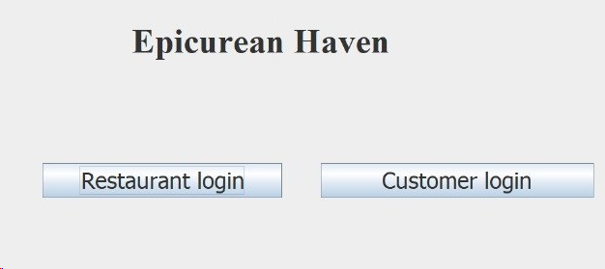

**Login page:**

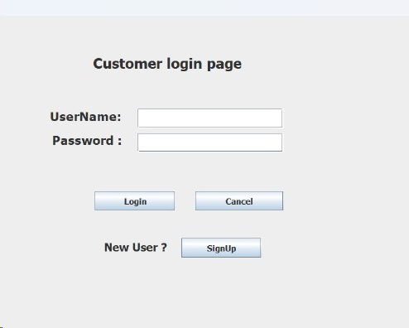

**Sign-up page:**

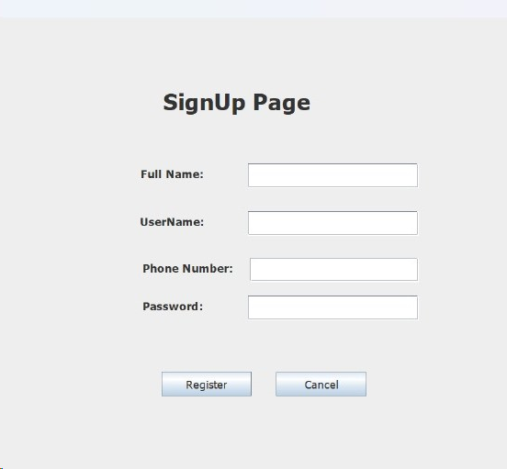

47

**Home page:**

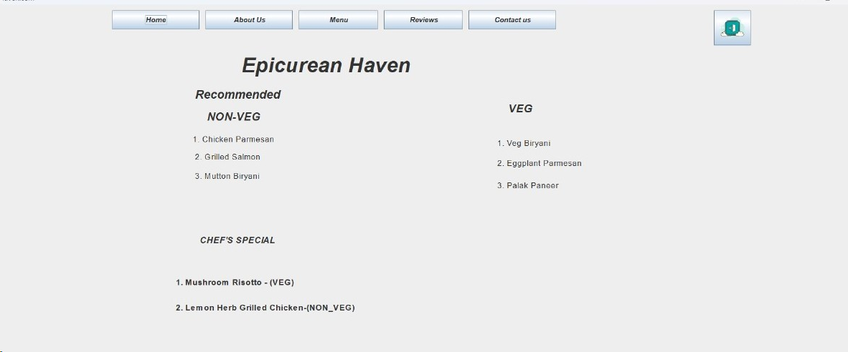

**Menu:**

**About us:**

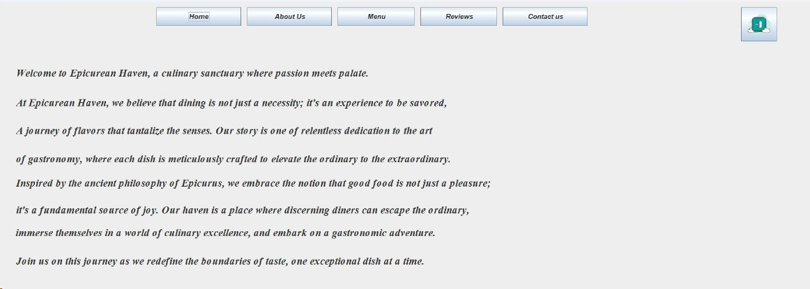

48

**Reviews:**

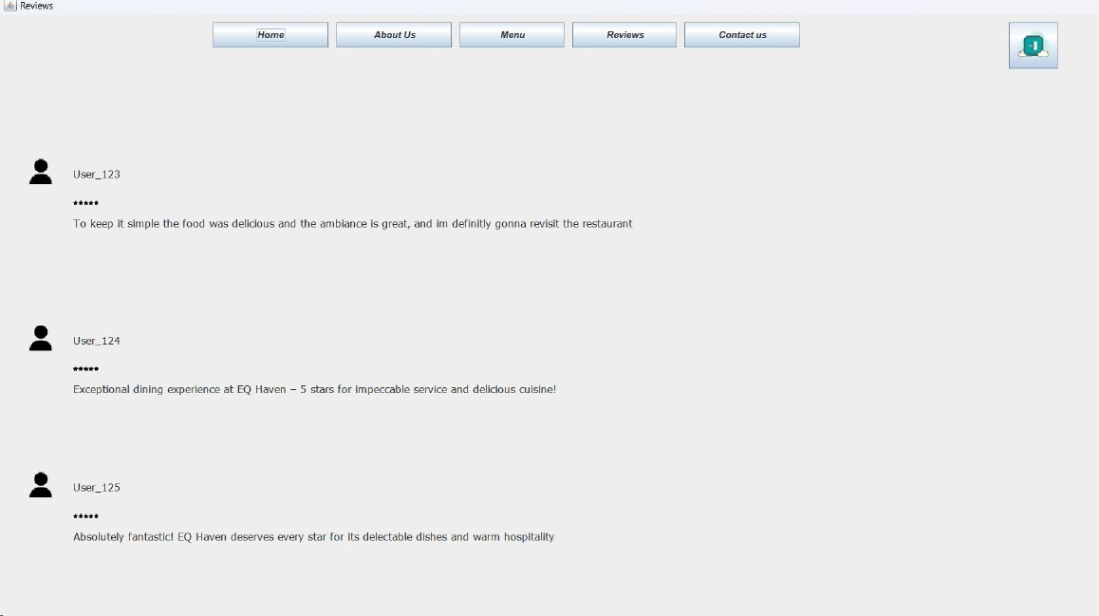

**Contact-us:**

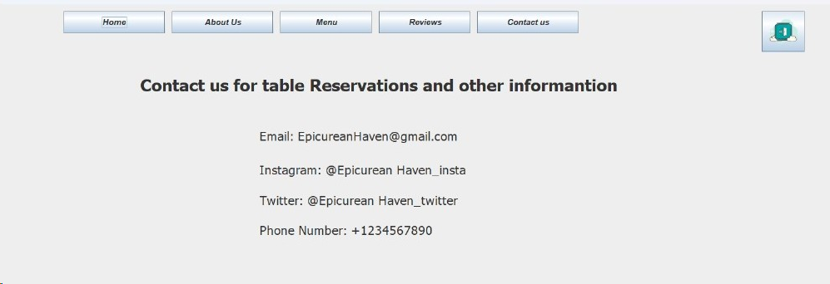

**Restaurant Login page:**

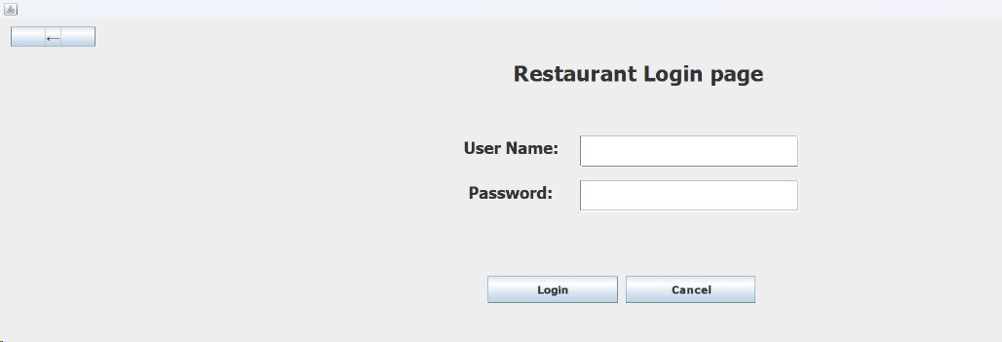

49

**Restaurant Management page:**

50

**CONCLUSION**

In a world where efficiency and customer satisfaction are paramount, our Restaurant Management System stands as a beacon of innovation. By empowering admins with dynamic menu control and envisioning future possibilities like direct table ordering, our system not only addresses current challenges but sets the stage for a technologically advanced and customer-centric dining experience

51